Hollis Veal

Comp3700

**Admin and Customer Design Document**

Customer(New purchase, List of Purchases, Cancel a Purchase)

Admin(System Config, Adding New User, Deleting Existing User)

Home Screen Admin:

Main Screen:

Idea:

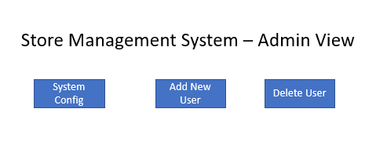

Finished Product:

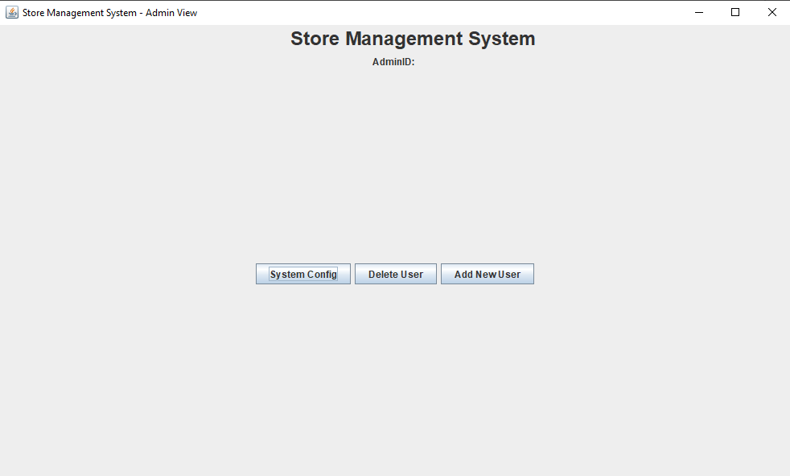

Home Screen Customer:

Main Screen:

Idea:

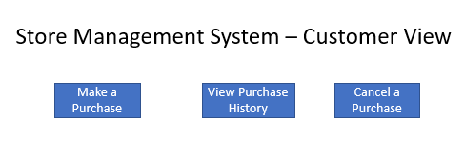

Finished Product:

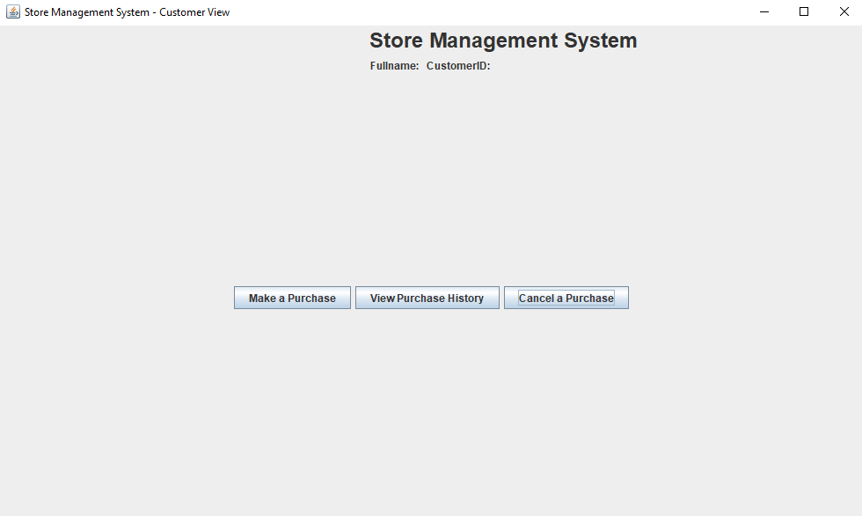

Business Logic:

Customer: Add or cancel Purchases and view old purchases

Admin: Admin needs to look at the system configuration and add or delete Users so he knows who uses the system.